Portfolio: SUP RES
Performance Summary Report
3/21/2022 - 3/21/2025
Performance Statistics Cumulative Return (%)
Total Return 3,097.70% $309,769.81 Average Annual Return 937.45% $103,256.60 Standard Deviation of Annual Returns 1,614.71% $182,721.13 Average Monthly Return 44.13% $17,209.43 Standard Deviation of Monthly Returns 33.37% $68,574.60 Average Daily Return 1.92% $862.87 Standard Deviation of Daily Returns 94.96% $16,563.20 Compounded Annual Return 1,027.80%
Compounded Monthly Return 22.04%
Percent Months Profitable 66.67% Percent Weeks Profitable 54.67% Percent Days Profitable 48.75% Best 12-Month Period Return 4,082.83% $408,283.46
Worst 12-Month Period Return 134.66% $183,500.89
Sharpe Ratio 0.4630
(rate=2.00%)
Maximum Drawdown -107.64% ($186,243.79) Maximum Drawdown Date 4/18/2024 3/13/2025 Longest Time Between Equity Peaks 99
Number of Trades 306 Total Units Traded 177,092
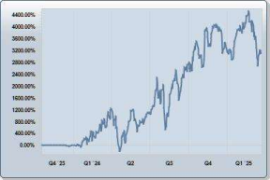Monthly Return (%) 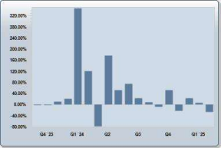
Average Trade 6.39% Ratio Average Win/Average Loss 1.29 Percent Profitable Trades 66.67% Profit Factor 2.59
$1,348.66
Monthly Return
Year Jan Feb March April May June July Aug Sep Oct Nov Dec Year 2023 0.00% 0.00% 12.14% 12.14% 2024 21.95% 348.29% 122.27% -78.71% 177.06% 52.73% 76.27% 23.63% 9.27% -6.70% 53.39% -22.20% 2,801.93% 2025 24.09% 6.72% -25.80% -1.74%


